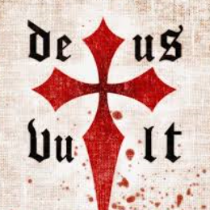

It came from a speech the Pope gave while gathering support for the First Crusade.

"Deus vult!", meaning "God wills it" was the battle cry of the Crusaders.