A Background to Christianity in Medieval Europe

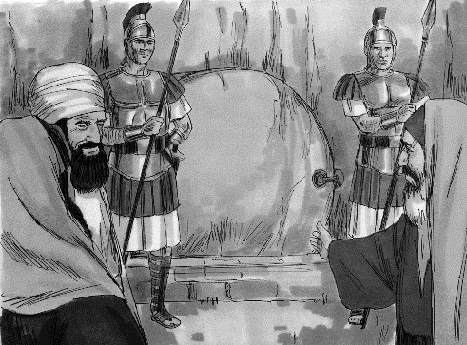
Medieval Europe was often referred to as Christendom because just about everyone was a Christian. At first, Roman rulers made every effort to stamp out Christianity across the empire. They had even crucified Jesus and placed soldiers to guard his tomb because they were afraid of Christ’s followers (Christians). But during the 4th century, Christianity was declared the official religion of ancient Rome.

Christianity in Rome became known as the Roman Catholic Church
(‘Catholic’ was Latin for ‘universal’ or ‘all encompassing’).

Christian beliefs and values had many positive effects on daily life, architecture, the arts and the justice system. However, they also unfortunately provided motivations for war, and justifications for some people’s prejudices and fears.

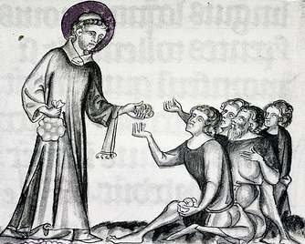
Medieval people were worried about where their souls would go after death. Had they lived a good enough life to go to heaven? Or had they been sinners and so would be tortured in hell forever? They lived their lives trying to show God they were good. They could do this by giving alms (that is, money) to the poor, or by going on a holy pilgrimage (a journey to a holy site).

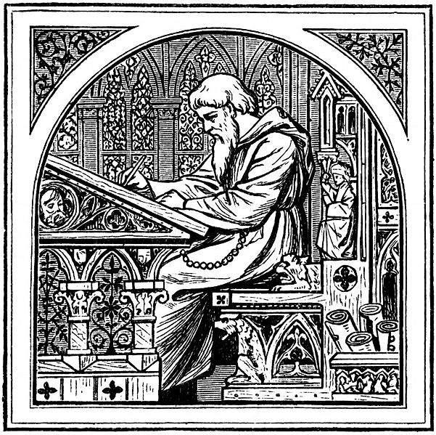

It was also common for people to join the church as priests, monks or nuns. They spent their lives either living in seclusion and worshipping god, or helping others. Wealthy merchants and noblemen gave money to build grand churches and cathedrals to show their goodness and to please god. Knights and noble lords sometimes went on crusades to fight for god. Other people would just try to live the best lives they could by following the laws of god and the church.

